GREENHOUSE ALARM
Section 2: Paired Prototype | Fall 2026 Friday | Jizhi Jin & Hector R. Medina
LOGLINE A top-down arena-survival shooter where a timed dash reflects incoming enemy shots, turning evasive movement into a counterattack.

Prototype
Move around a fixed arena while the player automatically fires at the nearest enemy. Survive pink two-hit melee chasers and orange one-hit ranged shooters, and use a timed Space dash to avoid and reflect pink enemy projectiles.
Controls WASD / arrow keys: move • Space: dash • R: restart after defeat
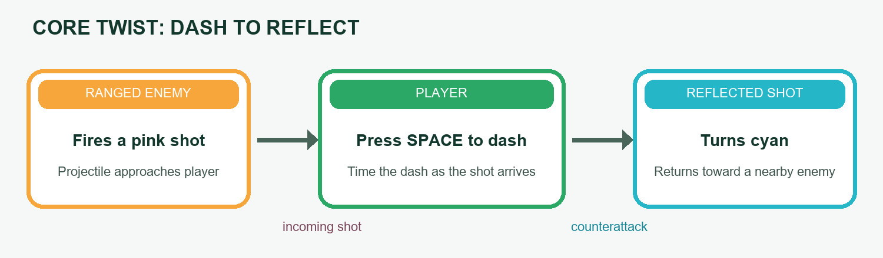
Mechanic sketch: time the dash as a hostile shot reaches the player; the reflected shot travels toward an enemy.

Twist & Mechanics Matrix
Name | Game Name | Mechanics Ideas | Core Mechanic | 2 Supporting Mechanics | Description
Jizhi Jin / Hector R. Medina | Greenhouse Alarm | Movement; auto-fire; dash | Dash through an incoming shot to reflect it | Auto-fire nearest target; melee and ranged enemies | A short, timed dash avoids damage and returns enemy fire toward a target.

Genre Research & Twist
• Brotato — A top-down arena shooter built around surviving enemy waves; automatic weapons and between-wave item choices are familiar genre features.
• Vampire Survivors — A time-survival game where the player weaves through monster crowds while weapons and upgrades build up over a run.
• 20 Minutes Till Dawn — A horde-survival shooter centered on active aiming, defeating monsters, and selecting upgrades to shape a build.
Shared genre pattern. These games create pressure with enemy crowds, ask the player to move while attacking, and use weapons or upgrades to improve survival. Greenhouse Alarm narrows the prototype to one repeatable skill test: a well-timed dash passes through an enemy projectile and sends it back toward a target. This makes defense an active counterattack and gives the player a reason to time movement against incoming fire.

Not Yet Implemented
The current build has no kill rewards, upgrade choices, levels, or camera switching. Planned additions include choosing a damage, fire-rate, or dash-cooldown boost after a kill milestone, and a first-person camera mode toggled by Tab. These are future ideas and are not playable in this prototype.

Team Contributions
Jizhi Jin: initiated the prototype direction, coordinated iteration and project integration, and prepared this descriptive document.
Hector R. Medina: contributed to discussion, design, and script writing.

Project Links
Repository: github.com/jizhijin/game-demo Playable build: GitHub Pages
Sources (official Steam descriptions)
• Brotato on Steam
• Vampire Survivors on Steam
• 20 Minutes Till Dawn on Steam

